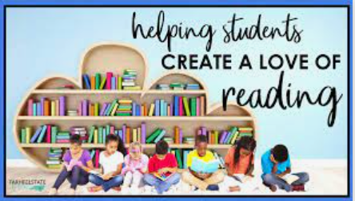

- Driver for our school (CERB)
- Red Ted for Reception – Year 3
- Reading challenges in all classes
- All classes our local library once a half term
- Events throughout the year e.g. WBD, book swap
- Dedication story time across the school
- Children have access to reading areas in all classes
- Cross curricular texts used to support holistic learning
- Love for reading books taken home each week
- Author of the term in all classes
- Daily readers
- Secrets to Success reading challenges
- Dedicated shared / guided reading time in all classes
- Daily phonics for all children who still need it
- High quality texts used across the school including resources from ELS
- School librarians

